**Pracovní list – listnaté stromy a jejich plody.** Spoj trojici = název stromu – list – plod.

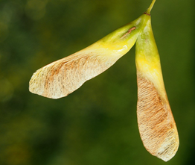Bříza bělokorá [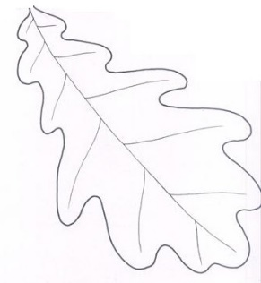](https://www.google.com/url?sa=i&url=http%3A%2F%2Fvytvarna-vychova.cz%2Ftag%2Fstrom%2F&psig=AOvVaw2AsRD5Ui1S0xJzoptCFSKq&ust=1585204483601000&source=images&cd=vfe&ved=0CAIQjRxqFwoTCMCZq4yBtegCFQAAAAAdAAAAABAD) 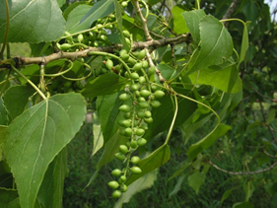

[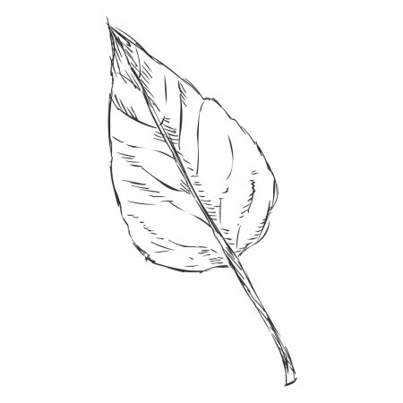](https://www.google.com/url?sa=i&url=https%3A%2F%2Fcz.depositphotos.com%2Fvector-images%2Ftopol-list.html&psig=AOvVaw2E9tV8_2DrXw2YFfFHHnC4&ust=1585206223536000&source=images&cd=vfe&ved=0CAIQjRxqFwoTCOjt9cGHtegCFQAAAAAdAAAAABAD) Javor mléč [](https://www.google.com/url?sa=i&url=https%3A%2F%2Fcz.clipart.me%2Fistock%2Fisolated-vector-monochrome-birch-leaf-112758&psig=AOvVaw2gmYsKHioUrSuMCE1FDFiw&ust=1585205186694000&source=images&cd=vfe&ved=0CAIQjRxqFwoTCPDj8-GDtegCFQAAAAAdAAAAABAJ)

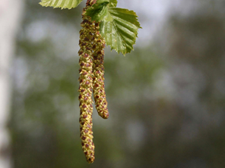

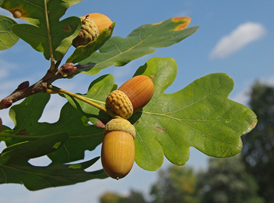Dub letní

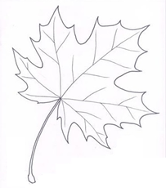

Jírovec maďal

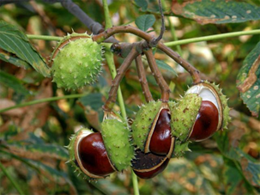

Topol černý [](https://www.google.com/url?sa=i&url=http%3A%2F%2Fchytrasova.blog.cz%2Fgalerie%2Fomalovanky%2Fpodzim%2Fobrazek%2F71127361&psig=AOvVaw04x7YRaqx0D4Pyl95fbDsC&ust=1585208152268000&source=images&cd=vfe&ved=0CAIQjRxqFwoTCOjXh-GOtegCFQAAAAAdAAAAABAJ)